CONTAINERIZE THE APP

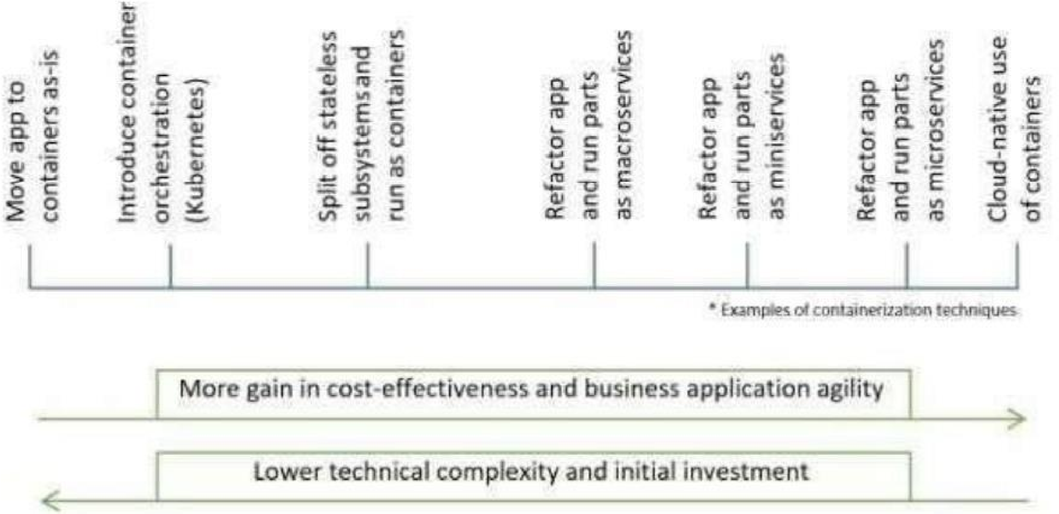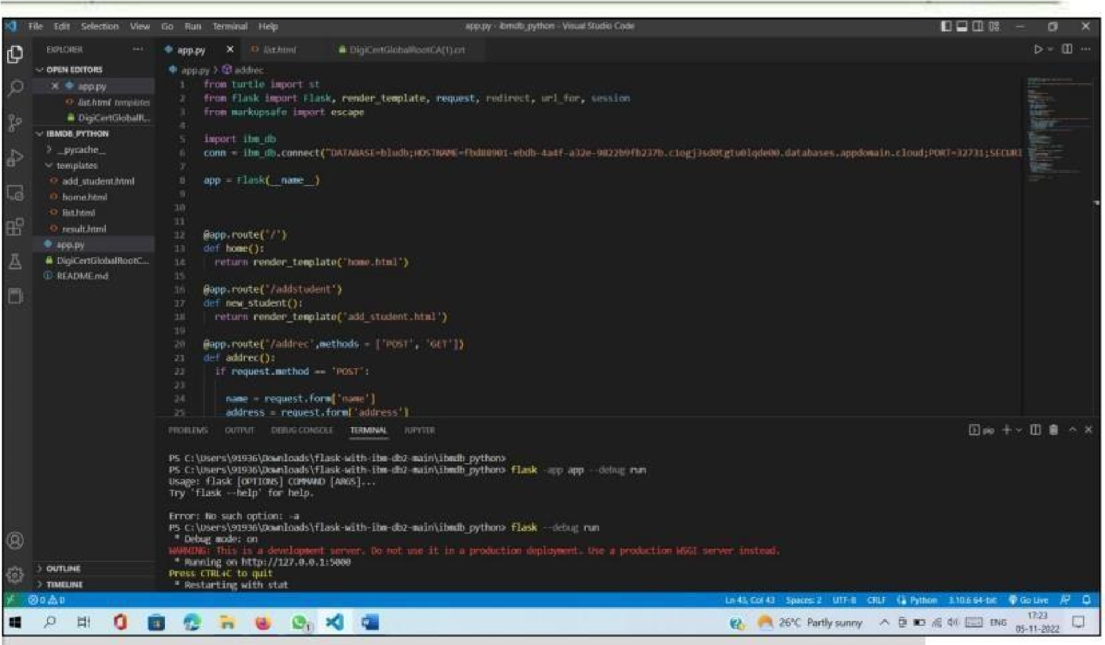

|  |  |
| --- | --- |
| **Team ID** | PNT2022TMID03890 |
| **Project Name** | **Project - SMART FASHION RECOMMENDER APPLICATION** |